GSoC 2013 Documentation 03 July 2013

To run an example of ‘RightClickMsgMenu’ to demonstrate the use of extension in OWASP ZAP

Prerequisites:
ZAP is compiling and running in Eclipse

Download the example folder. Go to the following location:
https://code.google.com/p/zap-extensions/wiki/Examples and click on Extension including a right click menu item

Place the folder into the package “org.zaproxy.zap.extension”

Go back to eclipse environment, Refresh the project by right-click the src folder under the project and select ‘Refresh’ from the drop down menu.

Right click the ‘src’ again and select Run

When the ZAP application would launch, right click in the left pane or the bottom pane of the ZAP window. You will see a new menu item as follows:

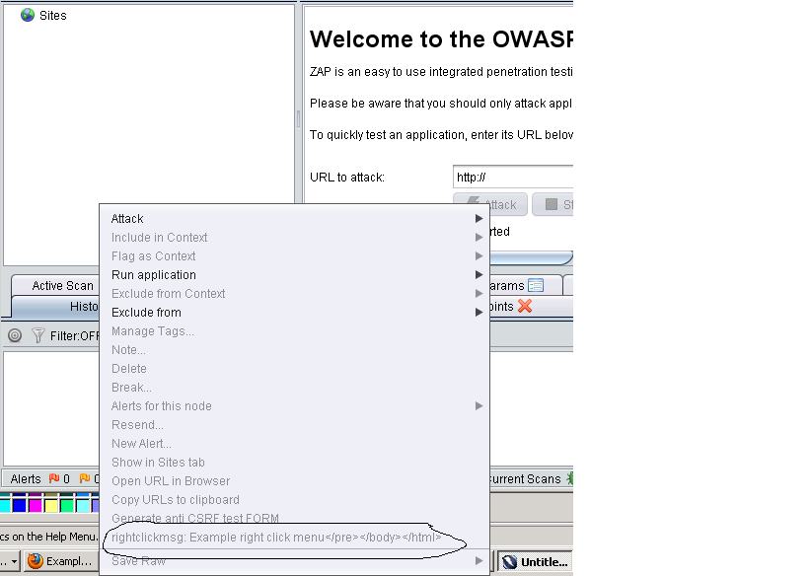
Figure: Right click menu option as an extension.

Background:
ExtensionRightClickMsgMenu is a class that ExtensionAdaptor class.

The method “public void hook(ExtensionHook extensionHook)” adds a new menu in the right hand menu.

getPopupMsgMenuExample() returns the control of the newly added right hand menu.

getMessageString (String key) sets the name of the newly added right hand menu.

